**Step 3.3 - Draw an E-R diagram to represent the enterprise**. Be sure to identify relationship participation and cardinality constraints, any weak entity sets, and role names, if needed.

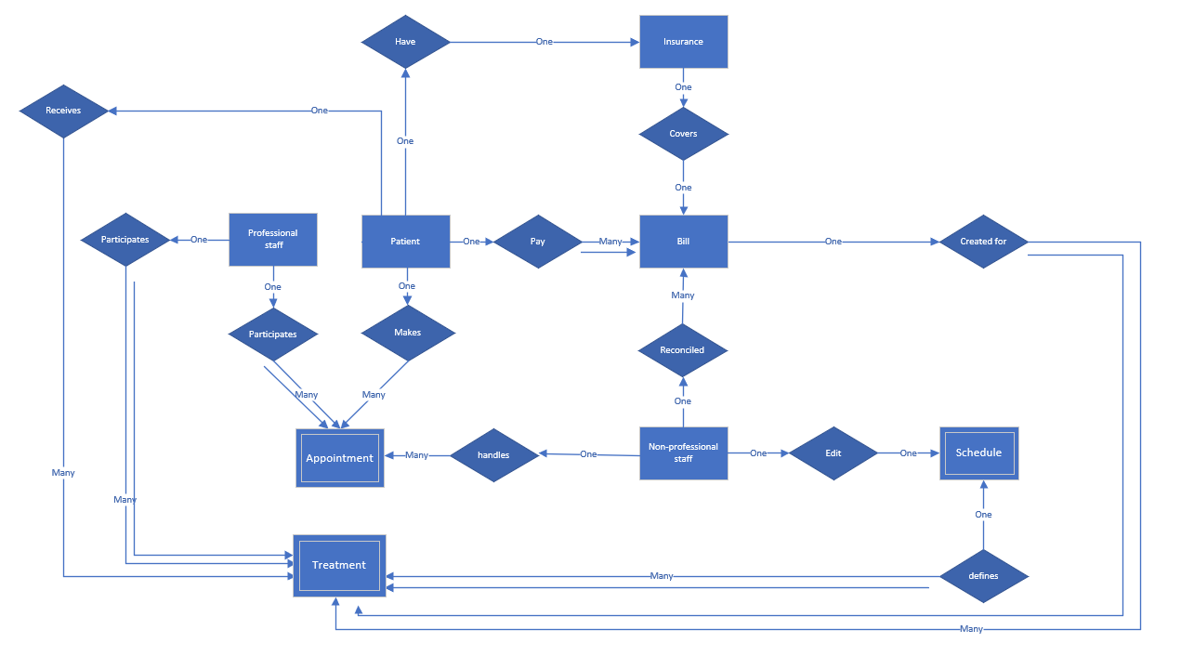

Picture 1 - The E-R diagram for the Clinic.

The E-R diagram is shown in *ER diagram Clinic Team 10.vsdx* file as well as on picture 1 below.

We start to describe the diagram from the Patient Entity (rectangle). The patient can make an appointment for the professional staff., so we created Makes Relationship and the Appointment Entity. The Appointment is a weak entity because it uses data from the Patient and the Professional Staff. Basically, we use patientID and staffID as superkey to describe rows there. The relationship is one-to-many with partial participation because the patient can leave the appointment or skip it. There can be an appointment without the patient.

The professional staff must participate and be assigned to the appointment meetings, so the Participate Relationship is total participation for them. Additionally, it is one-to-many due to the fact that one staff member can serve a plenty of patients there.

The patient may have only one insurance, so in the Have Relationship there is one-to-one connection with Insurance Entity. It has partial participation because the patient may not have the insurance. The insurance may cover the patient’s bill, so the Covers Relationship was created, which is one-to-one and partial. The insurance can cover only part of the payment, so the patients must pay something on their own. The Pay Relationship is one-to-many (one client can pay many bills) and total participation.

The bills are created for the treatment by Created For Relationship. The treatment is a weak entity, which brings data from different sources. It is one-to-many with total participation because one bill can be created for many treatments.

The non-professional staff can handle appointments. reconcile bills and edit schedules. For all of them, it is partial participation and one-to-many for Handles and Reconciled Relationships and one-to-one for Edit Relationship.

Schedule defines the treatment, so the Defines Relationship is one-to-many with total participation. Speaking about Patient, they receive the treatment, so their relationship is one-to-many with partial participation, whereas the medical staff must be in treatment, so it is one-to-many with total participation.